Macbeth Act 4 scene 1:

In act 4 scene 1 the witch es got o visit with Hecate’s and they reveal the vision, what the vision says, and Macbeth's reaction.

I have included an adapted organizer Assignment: Three Visions Graphic Organizer; students please revisit the text for clarification.

Reread Act IV, Scene i, first with just the audio (Arkangel, 2005), and then with the audio, following along in NO FEAR Shakespeare: Macbeth. This way, students reread the text twice and can check their understanding on the second reading by focusing on the printed text.

We review the scene and the information that should be on the graphic organizer for questions 1-3 (Student Work: Three Visions Questions 1-3). We will complete question 4 when we are done reading the play.

Scroll below to complete the handout.

We will discuss the Zoom next class and review the texts.

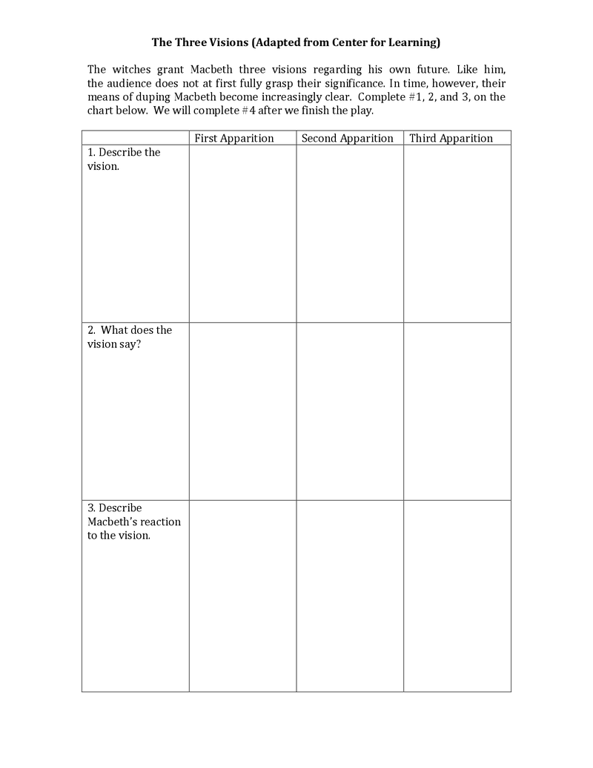
Complete the Chat and the questions and upload this document to One Note and title it Act 4 scene 1

