Honors English II Argumentative Essay #1 2018

Directions: Read the following sources and click the link provided to inform yourself on the topic. You will have to write an argumentative essay on the following concerns.

Florida has experienced a severe threat to their ecosystem that has affected the touristic income and local lifestyle. The one thing that makes people flock to this state seeking much needed sun and relaxation amidst the cool breeze is the very thing that is banned and advised to not enjoy. Below you will find three sources- a video link and two articles explaining how Florida’s panhandle has negatively been impacted by the Red Tide. After understanding the heart of the problem, write an essay that argues whether or not, you believe that the sugar cane industry is at fault for the fallout causing the Red Tide epidemic and should be held responsible, or argue that the Sugar Cane industry has no direct ties with this environmental phenomenon and should not accountable for the aftermath.
You must incorporate two quotations form any of the sources within your essay. Please write your paper without anyone’s influence since it will be used as a diagnostic exam.
Source 1: https://thenewtropic.com/algae-everglades-sugar/

Source 2:

Big Sugar scored a sweet deal that’s left Florida’s waterways a toxic mess
POSTED ON AUGUST 4, 2016 AT 11:00 PM.
WRITTEN BY ROSHAN NEBHRAJANI
When Mary Radabaugh first moved to Stuart 13 years ago, “it used to be like the Bahamas, crystal clear bathtub waters.”
But now, every couple of years, when the temperature is just right, a thick green mat of toxic algae settles on top of the water. It begins as a green slime, then slowly turns a deceivingly beautiful sky blue.
Within weeks, it rots into a white and brown speckled mass, with flies buzzing atop a reeking mound of mold and dead fish. The gelatinous gunk suffocates the fish below and releases toxins and into the air above.
“It starts burning your eyes, your throat, your nose,” she said from behind her desk at the Central Marina, just off of the St. Lucie Estuary and ground zero for toxic algae blooms. The marina has already lost 50 percent of its business during this year’s blooms, she says. No one wants to boat on these waters. Hear it from her below.
But while algae blooms devastate local estuaries, toxic airborne cyanobacteria keep residents up at night with headaches, and small businesses suffer… the 400,000 acres of sugar cane fields that line Lake Okeechobee are a lush, healthy green. As are the pockets of local, state, and federal politicians who have accepted more than $50 million in contributions from Florida’s sugar industry for decades. (Want a peek at the gravy train? We’ve got it.)
Radabaugh, like so many others in Stuart, used to spend all her time either in or surrounded by the water, which is usually a brilliant turquoise blue.
But now she can’t go near it — if it’s not because of the nauseating smell of the rotting algae and dead animals, it’s the unknown effects of the toxic chemicals in the water.
“I’ve had the watery eyes, I’ve had the headaches at night … all the common symptoms,” she` said.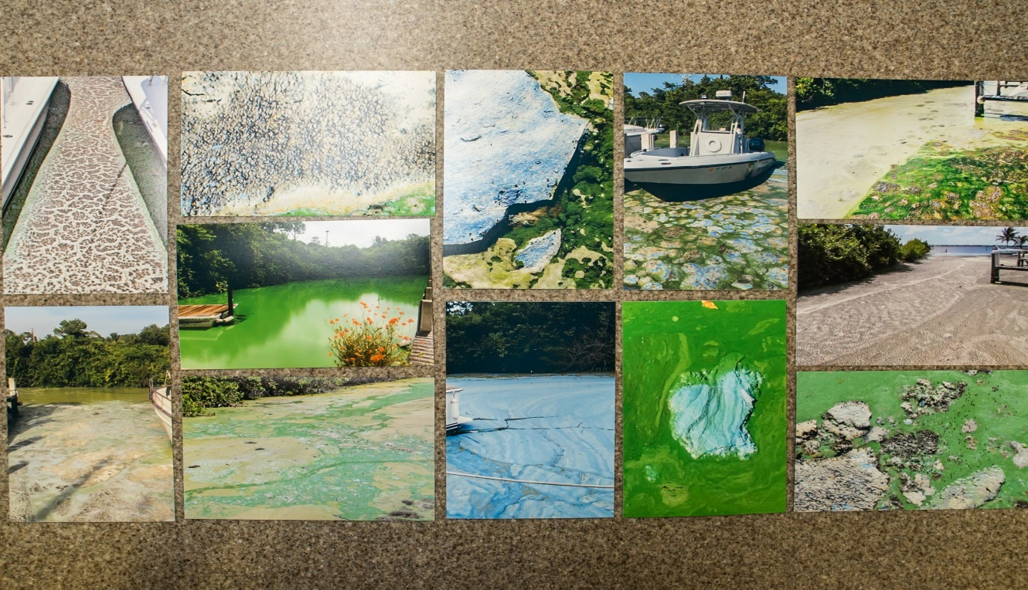
When the temperatures go back down a bit, the bloom simply settles on the river floor. At the Central Marina the bloom has gone from a thick mat on the water’s surface to virtually undetectable in just two weeks. But Radabaugh knows it will be back.
“If it’s in the right conditions it can rebloom … We’ve had almost three blooms in this particular section,” she said.
This blue-green algae feels like a foreign substance akin to something out of an M. Night Shyamalan movie, but it’s actually been around the earth since the beginning of time. It grows in ponds or lakes where the water is warm and full of nutrients like nitrogen and phosphorous, which act like a fertilizer, explained Paul Gray, Okeechobee Science Coordinator at the Florida Audubon.
How did this water get so full o1f nutrients? Historically, water flowed freely all the way from the Kissimmee River down to the southern tip of the state — it’s why renowned author and environmentalist Marjory Stoneman Douglas named the Everglades a flowing “river of grass.”
Here’s Gray mapping it out:
Over the years we’ve drained the Everglades to make cities (like Miami) and farmland where the water used to flow, effectively stopping it at Lake Okeechobee. When water flows south from the Kissimmee River to Lake Okeechobee, it brings a bunch of runoff from cattle and farming up north, as well as some human waste that escapes the sewage system, and dumps it into the lake, carrying nutrients like phosphorous and nitrogen.
The marshlands south of Lake O used to act as a natural water purifier. But now that the water is being diverted east and west to the coasts, it’s traveling without really being cleaned.
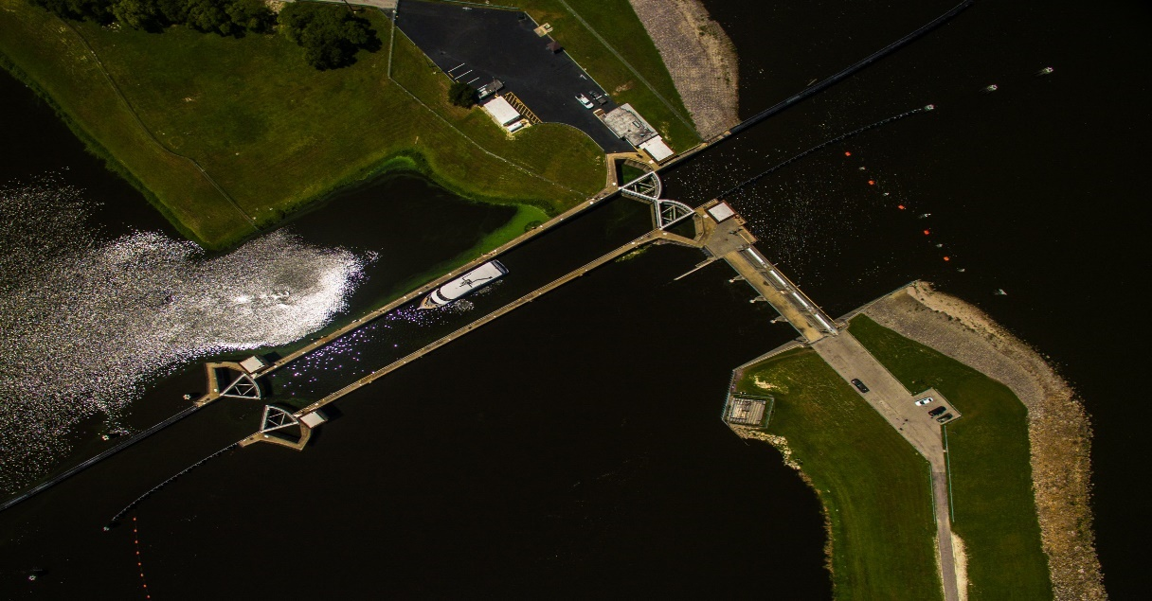
“A lot of people want to blame the farmers for everything, but if you flush your toilet in Palm Beach or even in Miami, some of that is up here,” Gray said. “It’s not just the farmers it’s all of us. Humans have a footprint and all of us need to be careful about how we deal with our waste and our nutrient streams.”
Right now most of that phosphorous-laden water is dumping out into the St. Lucie Estuary (aka the part where the river meets the ocean), where Radabaugh’s marina is.
Steven Davis, a wetland ecologist at the Everglades Foundation, suggests that the water flow from Lake Okeechobee into a massive reservoir (sort of like an above ground lake) until it can be cleaned by flowing through marshes, which would absorb the nutrients as the water flows through.
There’s one hitch: there are a bunch of sugar cane farms in the way. Check them out:

The role of Big Sugar
Directly below Lake Okeechobee, you’ve got the Everglades Agricultural Area — a 700,000-acre plot of fertile land that was drained and back pumped into Lake Okeechobee in 1948.
The major crop grown there today is sugar cane, and the farms are owned by three main companies, aka Big Sugar — The Fanjul Corp. (which owns Florida Crystals and Domino Sugar), U.S. Sugars, and the Sugar Cane Growers Cooperative.
Currently, sugar cane farming in Florida produces half of the total sugar in the United States. Florida’s sugar industry contributes to 18,600 jobs in Florida. For perspective, there are 8,324,500 jobs in Florida — so that’s just 0.2 percent of the employment.
The industry is valued at $677 million as of 2014, according to the Florida Department of Agriculture and Consumer Services — an itty bitty amount of Florida’s GDP, which totaled $769.7 billion in 2014.
Until 1959 the sugar industry in Florida was quite small. But after the Cuban Fanjul family’s farms were nationalized in the Cuban revolution, they fled to South Florida and bought up hundreds of acres of agricultural land.
The following year’s 1960 trade embargo on Cuba, coupled with government subsidies on sugar, meant that Florida’s sugar farms had no competition and all the freedom to grow.
As far back as 1934, the sugar industry has received subsidies and benefited from tariffs that use tax money to mass purchase sugar while keeping the the price of U.S. sugar artificially high. Basically, when sugar farms produce too much sugar, the United States Department of Agriculture just buys it up using tax dollars — this number changes every year, but the Congressional Budget Office’s March 2016 baseline for Farm program predicted the USDA would spend $138 million on buybacks of U.S. sugar over the next decade.
Right now, the global sugar price is 19.15 cents per pound, while the U.S. sugar price is 27.39 cents per pound. This means that taxpayers are subsidizing U.S. sugar production while still paying more at the supermarket for the sweet stuff.
Since the 1990s, Big Sugar has been able to fend off state water clean-up requirements and routinely leave us, the taxpayers, to pick up the bill for Everglades restoration efforts. In 1996, the sugar industry spent $35.7 million on campaigns to beat back an attempt from environmentalists to impose a sugar tax to raise $900 million to clean up the Everglades. Big sugar won the campaign, and Floridians voted against it by a 9 percent margin.
But in 2014, 75 percent of Floridians voted for Amendment 1, the Water and Land Conservation Amendment, which allocated $700 million for Everglades restoration. Then Big Sugar released the lobbyists and watered it way down.
“The legislators robbed us of that … it was unfortunate politics,” according to Gray of Florida Audubon. “We got ripped off, we’ve got these problems and we need money to spend it and they ran off and did something else with it so we’re trying to get that money to fix these problems.”
Just last year, a plan to buy 46,800 acres of U.S. Sugar land fell through, with the South Florida Water Management District saying it wasn’t worth it. Meanwhile the coasts continue to be pumped with polluted nutrient-rich water.
Florida Crystals says the algae blooms happening in Stuart are not caused by their farms, and technically this is true. The nutrients in the St. Lucie Estuary can come from a number of different sources, like old septic tanks, according to Randy Smith, spokesperson for the South Florida Water Management District.
But a history of backpumping (which is now illegal) into Lake Okeechobee to drain the land for the farms primed the area for blooms, according to Charles Lee, director of advocacy for Audubon Florida. And the inability for clean water to flow southward makes that problem worse.

The way forward
The way to fix it is to use the money from Amendment 1 to rebuild the state’s water management system and dig out a way to get the water flowing south from Lake Okeechobee, according to Gray, who breaks it down here:
What does that look like? You’ve got to cut through many of these farms with canals and buy enough land in the agricultural area for a 60,000-acre, 6-foot-high reservoir. That reservoir would be emptied into the Everglades during the dry season and filled and used as storage during the rainy season (kind of like what Lake Okeechobee does now).
You’ve also got to build artificial marshes and stormwater treatment areas to make sure the nutrient-rich runoff isn’t flowing directly into the Everglades, or we’ll see the same algae blooms that are happening in Stuart devastating the waterways below, according to Davis.
“We’ve got the plan, we’ve got the money. The only thing we’re not seeing is the will to make that happen,” Davis said.
And that lack of political will has probably got a little something to do with exorbitant campaign contributions from Big Sugar. From 1994 to 2016 the sugar industry contributed $57.8 million to local and state campaigns, according to the Miami Herald, spanning both Democrats and Republicans.
The sugar industry has given Gov. Rick Scott $28,250, Sen. Bill Nelson $46,900, and Sen. Marco Rubio $92,335, according to the National Institute on Money in State Politics — and they’ve already donated $37,954 to Hillary Clinton’s campaign this year alone, showing their quest for influence doesn’t stop at Florida. Follow the money at our story here. (We’ve got the full rundown of Big Sugar’s campaign donations over here.)
“The sugar industry really owns the field. It doesn’t make any difference whether they’re Republican or Democrat, they have their have hands in both [parties],” said Lee.
But this being an election year, some Martin County residents like Kenan Siegel are hoping to tip the scales. Five years ago, Siegel moved from Miami to Martin County with his family and thought he hit the lottery because it was so beautiful. But after just two years, discharges transformed his strip of paradise into a polluted mess.
He and two others started an organization called Bull Sugar, with the goal of stopping water from Lake Okeechobee from reaching Stuart, instead fixing the flow of freshwater into the Florida Bay.
“This has been something that has been happening for years. …. but this is an election year, it’s fortuitous. A lot of people are paying attention [because] we had this toxic blue-green algae which was horrible but it got us national media attention,” Siegel said. “In Florida government has the most power … we have to elect the people that are going to do the right thing.”

Source 3:

RED TIDE BY JERRY KUSTICH
POSTED ON APRIL 12, 2018
Jerry Kustich's books (including his latest, Holy Water) offer contemplative, insightful meditations on the peace and beauty of fly fishing. But this piece is different. Kustich grew up watching pollution destroy fisheries in his backyard and across the nation, and now he sees it happening in Florida.
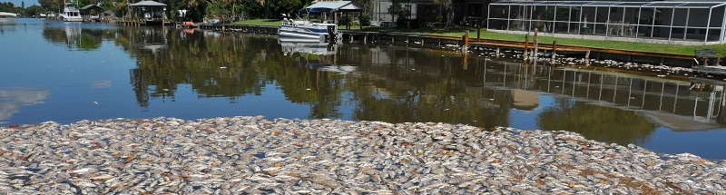
Norm warned me that I might see some dead fish. It was spring of 2004 and I was on Sanibel Island looking for a snook or two cruising the beaches near where Norm Zeigler’s fly shop was located. He told me that the area recently suffered an outbreak of red tide, one form of a dangerous toxic algae bloom that not only threatens the health of local residents, but sucks the oxygen from the surrounding water leaving a multitude of dead fish that had been trapped in this web of life-snuffing pollution. So, when I got to the water, at least I was prepared for what I was about to see.
Upon getting out of my vehicle it was the putrid stench that awakened my senses even before walking along the shoreline to witness a variety of fish floating belly-up in the shallows poaching in the eighty-degree heat. As I proceeded several yards up the beach, my eyes locked in on a huge one-hundred and fifty pound goliath grouper smoldering in the sun parked about fifty feet from the porch of a beautiful waterfront house emanating a wretched stink that most certainly was permeating the indoor sanctity of the home owner.
In an instant, my mind flashed back to the days of my youth in the 50s when such sights were commonplace on the Niagara River. Lifeless carp tangled in a carpet of thick, green slime stretching far along the dismal appearing shoreline was a way of life back then. And while the reek of fetid fish flesh wafted through an otherwise perfect Western New York summer afternoon, gagging for a breath of fresh air was the only way my friends and I could “enjoy” exploring the river’s edge. As kids we had no way of knowing that this was not normal.
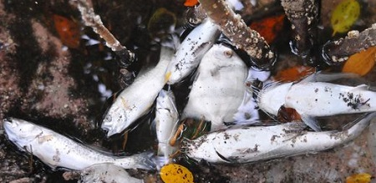
I recalled a day when my cousin Paul dared to wade through the green sludge of carp stew where he found a yellow bullhead writhing on the edge of this witch’s brew. It was barely alive and covered with a fuzzy gray fungus. My friend Johnny Joe was standing next to me on a rock embankment. As a prank Paul used his thumb and forefinger to pick up the whiskered fish by the tail and lob it in our direction. My friend didn’t see it coming, but he screamed holy hell when the bullhead’s spinney dorsal fin pierced his upper arm and hung there like a crucifix. The grotesque creature wriggled. Johnny Joe ran. And I was dumbfounded. Lake Erie was dying, and so was the Niagara. I didn’t know that at the time. In a very real way the River was stolen from my youth, and that bullhead squirming on my friend’s arm hung as testimony to an ecosystem struggling at death’s door thanks to the wanton practices of unchecked industrial plunder.
After spending much of my adult life trying to find water that wasn’t impacted by man’s errant activities, on that May afternoon I have to admit that the Sanibel beach experience triggered a PTSD type of reaction. To the core I was pissed. When I quizzed Norm about the background of the problem, it sounded extremely complex. What I did understand, however, was that the situation was connected to the heavily subsidized sugar industry and its ability to control legislators on the state and federal levels for decades. At that time these red tide occurrences were intermittent, and according to Norm, he and many other business leaders were led to believe that there were fixes in the works aimed at preventing these atrocities from happening again. But from my point of view, it was beyond incomprehensible that even one of these events had occurred without major backlash.
As I noted to Norm, folks spend a lot of time, money and effort to visit Florida. I know for darn sure smelling rotten fish is not part of the deal. I then asked how it was even possible in this day and age that one industry could impact the investments of so many homeowners and threaten the livelihoods of so many businesses without any pushback. If I lived there, I told him, my first instinct would be to take a load of these dead stinkers and throw them on the lawns of the legislators and sugar CEOs who are ignoring the rights of other taxpaying citizens and the tourists who bring substantial money into the state.
To tell the truth, I dismissed this depressing experience as a onetime glitch in a system that would surely be fixed as soon as any reasonable group of lawmakers caught wind of a situation that smelled to high heaven. For certain they could understand what the value a vibrant fishing industry meant to Florida’s overall tourism economy. Once they realized the Golden Goose was dying, undoubtedly any legislator with a functioning brain would step in and demand change. But it was not until 2017 when I saw a national news report featuring thousands of fish floating in the St. Lucie River as a result of the sugar industry’s transgressions that I realized not one thing had been done since 2004 to mitigate the destructive forces killing Florida waterways. For the sake of an industry estimated at anywhere between 500 million and 1.5 billion dollars per year Florida’s 10 billion dollar sport fishing industry and the property values of a substantive number of residents were being ravaged by a political industrial juggernaut that apparently could not give a dam about the rights of everyday citizens. After my experience growing up in the Great Lakes, it was hard to believe that this type of open environmental degradation could ever be allowed to occur again in the United States. How could this happen?
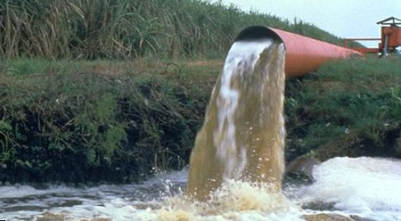
In a quick summary, it all focuses around the massive but shallow Lake Okeechobee in south central Florida. In the days before man settled Florida, the overflow of fresh water from the Lake would percolate on through the massive marshland and mangrove forests while nourishing multitudes of life forms and replenishing the aquifer that would eventually provide drinking water for the Miami area. This vibrant ecosystem impacted the web of life all the way to the Florida Keys. But when settlement was expanded in the Sunshine State, the federal government drained portions of the giant marsh through a series of dredged canals that then made the coastal regions of the state habitable in the 20s. In 1931 Charles Stewart Mott founded US Sugar after the upper portion of the marsh below Lake Okeechobee was also drained and set aside for producing sugar cane. Although the resulting land provided poor quality growing conditions, the heavy usage of phosphates and nitrates made it possible, especially after factoring in subsidies from the federal government which, by the mid 30s, protected the marginal industry by federal law. After the Cuban revolution in 1959 resulted in an embargo on Cuban sugar imports, a Cuban sugar magnate refugee Alfonso Fanjul came to the states and essentially took over a large portion of Florida’s industry as more swamps were drained using dikes, levees and pumps to grow more cane. This land has officially been designated the Everglades Agricultural Area (EAA). Over time his family run enterprise became a powerful entity and now controls much of what goes on in southern Florida. Through political wrangling and campaign funding of politicians on both sides of the aisle, the sugar industry has subsequently influenced water management for decades while the balance of Florida’s citizens and its tourism industry suffer the consequences.
The only portion of southern Florida that had escaped total degradation was the Everglades National Park given protected status in 1947. But unfortunately the Everglades has been languishing from the fallout of big sugar activities over the years as well. The Park is not getting the free flow of fresh water needed from the northern marshes that is controlled by the industry, thus threatening much of its ecosystem. These days much of the water once destined for the Everglades is held back in Lake Okeechobee by the Herbert Hoover Dam. There, regulated amounts of water are released to the cane fields for irrigation. However, when the water level behind the dam gets too high, the excess is redirected to the St. Lucie River that empties into the Atlantic past the coastal city of Stuart and also into the Caloosahatchee River that runs westward past Sanibel Island and out to the Gulf of Mexico. Because of the shallow nature of the lake the phosphate level deposited over the years through back pumping water from the EAA is extremely concentrated. As a consequence this nutrient laced release produces toxic algae growth in the freshwater estuaries and various forms of red tide algae blooms in the saltwater. Some of these blooms are capable of killing any life caught in the polluted web, and over the past decade it would seem that the situation has hit critical mass.
In 2017 SB10 was passed by Florida’s legislature and it accelerates planning and provides funding for an EAA reservoir that, according to the Comprehensive Everglades Restoration Plan, will provide needed water storage, treatment, and conveyance south of Lake Okeechobee. The plan is to reduce harmful discharges to the estuaries and send treated water south to the Everglades and Florida Bay. Some believe, however, this plan is not ambitious enough and will still result in toxic discharges into the St. Lucie and Caloosahatchee Rivers in the future. Updated information can be obtained from Bullsugar.org - a group dedicated to protecting Florida’s waterways while promoting the #NowOrNeverglades petition. The Now or Neverglades coalition includes but acts independent of the Everglades Foundation and is “the unifying voices of Florida and visitors, local, state and national elected officials, families, boat captains, fishermen and environmental conservation groups, Republicans and Democrats, and businesses – small and large – who have come together to save America’s Everglades and Florida’s water.”
In June 1969 Ohio’s Cuyahoga River, a Lake Erie tributary, caught on fire. This was not the first time the river had burned, but it would be the last. The residents of Cleveland spoke out. Finally the citizens of Ohio had enough of the industrial pollution that they had endured for decades in the name of progress. The time was right for change. Because President Richard Nixon had run his 1968 campaign on cleaning up the environment, Cleveland mayor Carl Stokes capitalized on the burning river story that made the cover of Timemagazine. Along with his brother, US representative Louis Stokes, they instigated a push for federal involvement in national pollution control. In 1970 the National Environmental Policy Act was initiated that resulted in the formation of the Environmental Protection Agency. The agency then advocated for the Clean Water Act, which was signed into law by President Nixon in 1972. As a consequence, that very piece of legislation has led to major water reclamation projects throughout the United States since that time. Thanks to the environmental movement that started in 1970 the extensive Great Lakes basin is now a vastly improved ecosystem and a significant economic driving force for the entire region. Although the Great Lakes are still not free from continued environmental threats, there are no longer dead, bloated carp and dying, fuzzy bullheads floating in the Niagara River either.
The way I see it, the St Lucie River, the Caloosahatchee River and the Everglades are all burning, we just can’t see the flames. Enough is enough. Now is the time for a change.

