For Filipino families, parols (stars) are the ultimate holiday decorations! Christmas culminates in a big parade in which everyone shows off their fringed stars.
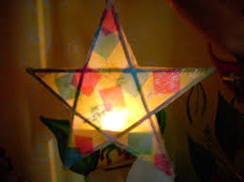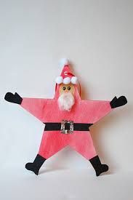
They can be decorative on one side but he other side has to have the writing.

What You Need:
- Colored tissue paper
- Graph paper
- Scrap yarn
- Craft glue
- Newspaper
- Pen
- Ruler
- Five identical 8½“ chopsticks or thin wooden dowels cut to 8½“
- Thin string or wire
- Scissors
- Shiny star appliqué (optional)
- Non-toxic markers (optional)

What You Do:
- On the graph paper, have your child draw a five pointed star, with each 9" long.
- Ask your child to lay the chopsticks on top of the pattern.
- Tie the chopsticks together at each of the 5 points.
- Help your child to make a loop at the top point for hanging.
- Tie the 5 additional points where the dowels intersect together.
- Now have your child cut out two 9” square pieces of tissue paper.
- Cover your work surface with newspaper.
- Invite your child to apply craft glue to the entire top surface of the star.
- Show your child how to place one tissue paper square over the star, covering all points, and pressing gently into place.
- Let the glue dry.
- Have your child cut away excess tissue paper.
- Switch to a clean sheet of newspaper.
- Ask turn the start over, and repeat steps 8 through 11.
- Apply your star appliqués in the center of each side if desired. Use a very small amount of glue.
- Instruct your child to cut three 3” lengths of scrap yarn, and fold in half.
- Tie off your tassel at the folded end, and glue tie to one point of the star.
- Repeat Step 16 four times, until you have a tassel at each point.
- With your family, choose a place of honor to hang the star.
For the Written Portion
Take whatever excerpt from a holiday story and customize it and make it your own.
Or, creatively write a holiday cheer.
Write a holiday poem. Create an Acrostic poem with a festive word or your name. 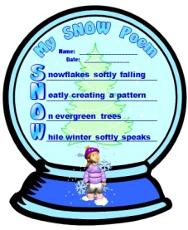
Whatever you chose to do …it should be on your ornament. If you want to get creative with the ornament, you can, it does not have to be a star only…any festive shape will do.
I will totally check for plagiarism!!! Beware!

