Definition of Enjambment
Enjambment, derived from a French word enjambment, means to step over or put legs across. In poetry it means moving over from one line to another without a terminating punctuation mark. It can be defined as a thought or sense, phrase or clause in a line of poetry that does not come to an end at the line break but moves over to the next line. In simple words, it is the running on of a sense from one couplet or line to the next without a major pause or syntactical break.

Features of an Enjambment

- Enjambment lines usually do not have a punctuation mark at the end.
- It is a running on of a thought from one line to another without final punctuation.
- It is used in poetry to trick a reader. Poets lead their readers to think of an idea then, on the next line, give an idea that conflicts it.
- Poets can achieve a fast pace or rhythm by using enjambment.
- Multiple ideas can be expressed without using semi-colons, periods and commas.
- It helps reinforce the main idea that might seem to be confusing with pauses.
- It can be seen in different songs and poems.
- It helps readers to continue thinking about the idea which is expressed in one line and which continues through to the next.

Definition: Caesura
We all speak. We all breathe. We all take breaths when we speak. When we say, 'Julie made the finals in track,' we take a breath before saying 'But Brian didn't,' and then another breath before saying, 'He fell and sprained his ankle.' These pauses (besides allowing us to speak without suffocating) form the natural rhythms of our speech. Just as there are pauses in our speech, there are pauses in the lines that make up a poem. These pauses have a name.
A caesura is a pause in a line of poetry that is formed by the rhythms of natural speech rather than by metrics. A caesura will usually occur near the middle of a poetic line, but can also occur at the beginning or the end of a line. In poetry, there are two types of caesural breaks: feminine and masculine. A caesura is usually indicated by the symbol //, but can be indicated by a single crossed line.

UNSCRATCHABLE ITCH: by Shel Silverstein

There is a spot that you can't scratch
Right between your shoulder blades,
Like an egg that just won't hatch
Here you set and there it stays.
Turn and squirm and try to reach it,
Twist your neck and bend your back,
Hear your elbows creak and crack,
Stretch your fingers, now you bet it's
Going to reach -- no that won't get it--
Hold your breath and stretch and pray,
Only just an inch away,
Worse than a sunbeam you can't catch
Is that one spot that
You can't scratch.

from A Light in the Attic by Shel Silverstein, 1981, Harper & Row

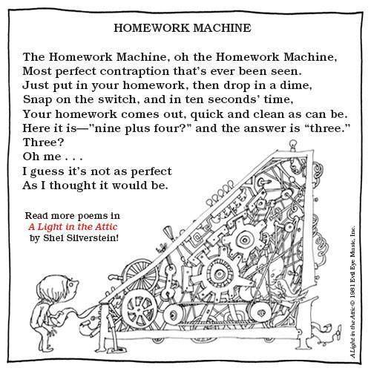

Honors Classes 2 Poems:

My Father's Corpse
by Andrew Hudgins

He lay stone still, pretended to be dead.
My brothers and I, tiny, swarmed over him
like puppies. He wouldn't move. We tickled him
tracing our fingers up and down his huge
misshapen feet — then armpits, belly, face.
He wouldn't move. We pushed small fingers up
inside his nostrils, wiggled them, and giggled.
He wouldn't move. We peeled his eyelids back,
stared into those motionless, blurred circles. Still,
he wouldn't, didn't move. Then we, alarmed,
poked, prodded his great body urgently.
Diddy, are you okay? Are you okay?
He didn't move. I reared back, gathered speed,
and slammed my forehead on his face. He rose,
he rose up roaring, scattered us from his body
and, as he raged, we sprawled at his feet – thrilled
to have the resurrected bastard back.

"What lips my lips have kissed, and where, and why"
by Edna St. Vincent Millay (1892-1950)
What lips my lips have kissed, and where, and why,
I have forgotten, and what arms have lain
Under my head till morning; but the rain
Is full of ghosts tonight, that tap and sigh
Upon the glass and listen for reply,
And in my heart there stirs a quiet pain
For unremembered lads that not again
Will turn to me at midnight with a cry.
Thus in the winter stands the lonely tree,
Nor knows what birds have vanished one by one,
Yet knows its boughs more silent than before:
I cannot say what loves have come and gone,
I only know that summer sang in me
A little while, that in me sings no more.
Regular Classes 2 Poems:
Wheels by: Jim Daniels
My brother kept
in a frame on the wall
pictures of every motorcycle, car, truck:
in his rusted out Impala convertible
wearing his cap and gown
waving
in his yellow Barracuda
with a girl leaning into him
waving
on his Honda 350
waving
on his Honda 750 with the boys
holding a beer
waving
in his first rig
wearing a baseball hat backwards
waving
in his Mercury Montego
getting married
waving
in his black LTD
trying to sell real estate
waving
back to driving trucks
a shiny new rig
waving
on his Harley Sportster
with his wife on the back
waving
his son in a car seat
with his own steering wheel
my brother leaning over him
in an old Ford pickup
and they are
waving
holding a wrench a rag
a hose a shammy
waving.
My brother helmetless
rides off on his Harley
waving
my brother's feet
rarely touch the ground-
waving waving
face pressed to the wind
no camera to save him.

from Places/Everyone, 1985
Fast Break
A hook shot kisses the rim and
hangs there, helplessly, but doesn't drop,
and for once our gangly starting center
boxes out his man and times his jump
perfectly, gathering the orange leather
from the air like a cherished possession
and spinning around to throw a strike
to the outlet who is already shoveling
an underhand pass toward the other guard
scissoring past a flat-footed defender
who looks stunned and nailed to the floor
in the wrong direction, trying to catch sight
of a high, gliding dribble and a man
letting the play develop in front of him
in slow motion, almost exactly
like a coach's drawing on the blackboard,
both forwards racing down the court
the way that forwards should, fanning out
and filling the lanes in tandem, moving
together as brothers passing the ball
between them without a dribble, without
a single bounce hitting the hardwood
until the guard finally lunges out
and commits to the wrong man
while the power-forward explodes past them
in a fury, taking the ball into the air
by himself now and laying it gently
against the glass for a lay-up,
but losing his balance in the process,
inexplicably falling, hitting the floor
with a wild, headlong motion
for the game he loved like a country
and swiveling back to see an orange blur
floating perfectly through the net.

from Wild Gratitude, 1990 Knopf

